http://peakenergy.blogspot.com/2008/01/alternative-wind-power-experiments.html
(accessed on 24 Oct 2010).
Windpower is currently the fastest growing renewable energy source (in terms of capacity - solar has a faster percentage growth rate), and looks like remaining so into the next decade. While most attention is focussed on the mainstream approach of generating power using large wind turbines - both onshore and, as Jerome recently looked at, offshore - there are a wide range of alternatives being considered for harvesting energy from the winds. In this post I'll look at 2 approaches that have received some attention in the press recently - attaching kite sails to ships and airborne wind turbines.
SkySails and KiteShips - Using Wind Power To Make Shipping More Fuel Efficient
Shipping is the most energy efficient way of transporting goods around, and it therefore likely to be increasingly important for trade as the availability of fossil fuels decreases and the cost of these increases. According to the Financial Times, it often now costs more to ship a container by road 100km from a port to its final destination than it does to move the container by sea from China to Europe.
One way of increasing the energy efficiency of shipping is to increase the size of the vessel, which big shipping operators like Maersk are already pursuing. Another way to reduce fuel consumption for shipping is being promoted by German company SkySails - attaching a kite the size of a football field to a vessel and using wind power to help save fuel costs.
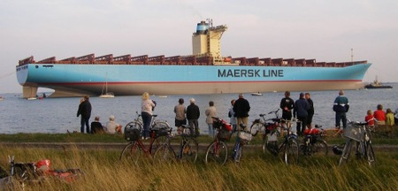
The SkySails apparatus consists of a towing kite with rope, a launch and recovery system and an automatic control system. Autopilot software monitors data from the sail and makes adjustments to ensure the sail is set at its optimal position. The company also offers a weather-based routing system to help ships sail in optimal wind conditions. The kites usually fly around 1000 feet above sea level where winds can be up to 50% stronger than at deck level.
The first ship using the system, the Beluga Skysail, is expected to set off from Germany this month (The Guardian says it is bound for Venezuela while The Times says it will, fittingly, be hauling windmills from Esbjerg, Denmark to Houston, Texas). Once it is well clear of the land, it will launch a 160 sq metre kite, which wind tunnel tests and sea trials suggest will tug it along and save 10-15% of the oil it would normally burn. In time it will be fitted with a larger kite, possibly saving 30-35% on fuel. One estimate predicts this could save around US$10 million over the lifetime of a vessel.
The Guardian quotes Christine Bornkessel from the Beluga shipping line, which has 52 merchant vessels, as saying "This is a serious attempt to reduce bunker [fuel] costs and polluting emissions. The kite will be used whenever it is possible on the voyage, and we are convinced it will revolutionise cargo shipping. We would consider fitting them to all our ships".
The SkySails company has ambitions to roll out the kites quite rapidly - “About 1100 of the 1900 newly built vessels joining the world’s merchant fleet each year are destined to be outfitted with SkySails propulsion”.
If the Beluga performs well on wind power and if the high-flying kites dramatically cut its fuel consumption, then the age of sail will be back.
“It marks the beginning of a revolution in the way that ships are powered,” said Stephan Wrage, the inventor of the SkySails idea. “We calculate that the sails can reduce fuel consumption by between 30 and 50 per cent, depending on the wind conditions. “The system could be applied to about 60,000 vessels out of the 100,000 or so listed in the Lloyd’s register. Bulk carriers, tankers — they could all benefit from the flying sails.”
Orders are already coming in, ranging from trawlers to a super-yacht. If he realises his dream of re-equipping the world fleet, Mr Wrage calculates that his sails could save 142 million tonnes of CO2 a year, equivalent to about 15 per cent of Germany’s total emissions.
The 35-year-old engineer, who came up with the idea as a teenager when he found himself being dragged by a kite along a blustery North Sea beach, is not the only person brooding about how exactly to reduce the gases released by the world’s shipping fleets.
The problem is huge. Merchant ships, which carry 90 per cent of the world’s merchandise, produce more sulphur dioxide than all the cars and lorries on the planet. And, according to the International Council on Clean Transportation, they also generate about 27 per cent of the world’s nitrogen oxide emissions.
Wallenius Wilhelmsen Logistics, the Norwegian fleet management company, has designed a green flagship, the Orcelle, which will use rigid, rotating sails to capture the strongest winds. When the wind drops the sails can be used as solar panels. But the company admits that it could take 15 years before the ship is developed.
The most straightforward way of reducing sea-borne pollution would be to impose a speed limit on the oceans. Carbon emissions would drop by 23 per cent if ships cut their speed by 10 per cent — but shipping experts say that slower cargo movements would lead to more vessels being deployed, and pollution would return to its former levels. ...
The sails, made of an ultralight synthetic fibre, are shot up as much as 300m (984ft) into the sky. ... Mr Wrage calculates that most ship owners should be able to recoup their £290,000 investment in the kite sails within three years.

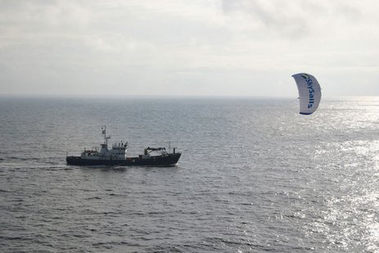
Drawbacks associated with this scheme include the additional costs associated with the kites - both with buying, installing and maintaining them, and with training and rostering crew members to tend them.
Skysail isn't the only company investigating the kite sail idea - US company KiteShip is building large kites, mostly for yachts, and plans to expand into the larger cargo and cruise ship markets.

